 | 7.0.19 Editors - 3D Viewport - Armature - Pose Mode - Pose context menu

Table of content
Detailed table of content 1
Pose Mode - Pose Context Menu 3
Insert Key frame 3
Insert Key frame with Keying Set 3
Copy Pose 3
Paste Pose 3
Paste X Flipped Pose 3
Rename active Bone 4
“Push Pose from Breakdown 4
Relax Pose to Breakdown 4
Blend to Neighbour 6
Calculate Motion Paths 7
Clear Motion Paths 8
Update Armature Motion Paths 8
Move to Bone Collection 8
Show Hidden 8
Hide Selected 9
Hide Unselected 9

Detailed table of content
Detailed table of content
Detailed table of content 1
Pose Mode - Pose Context Menu 3
Insert Key frame 3
Insert Key frame with Keying Set 3
Copy Pose 3
Paste Pose 3
Paste X Flipped Pose 3
Last Operator Paste Pose 4
Flipped on X Axis 4
On Selected Only 4
Rename active Bone 4
“Push Pose from Breakdown 4
Last Operator Push Pose 4
Percentage 4
Previous Key frame 4
Next Key frame 4
Channels 4
Axis Lock 4
Relax Pose to Breakdown 4
Last Operator Relax Pose to Breakdown 5
Percentage 5
Previous Key frame 5
Next Key frame 5
Channels 5
Axis Lock 5
Pose Breakdowner 5
Last Operator Pose Breakdowner 5
Percentage 5
Previous Key frame 5
Next Key frame 5
Channels 5
Axis Lock 6
Blend to Neighbour 6
Last Operator Blend to Neighbour 6
Factor 6
Previous Keyframe 6
Next Keyframe 6
Channels 6
Axis Lock 6
Calculate Motion Paths 7
Display Type 7
Around Frame 7
In Range 7
Computation Range 7
All Keys 7
Selected Keys 7
Scene Frame Range 7
Manual Range 7
Bake Location 7
Heads 7
Tails 8
Last Operator Calculate Bone Paths 8
Clear Motion Paths 8
Last Operator Clear Bone Paths 8
Only Selected 8
Update Armature Motion Paths 8
Move to Bone Collection 8
New Bone Collection 8
Bone List 8
Show Hidden 8
Hide Selected 9
Last Operator Hide Selected 9
Unselected 9
Hide Unselected 9
Clear User Transforms 9
Last Operator Clear User Transforms 9
Only Selected 9

Pose Mode - Pose Context Menu
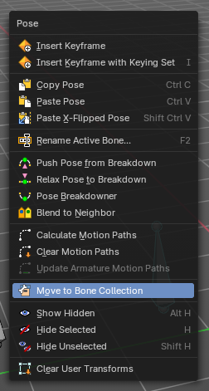
Call this menu with double right click in the 3D viewport. You need to be in Edit mode with an armature object.

Insert Key frame
Inserts a keyframe and uses the default keying set defined in the preferences.

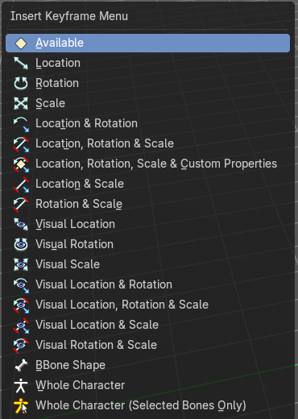
Insert Key frame with Keying Set
Opens a menu where you can insert a key frame with a defined keying set.

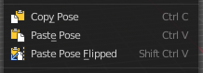
Copy Pose
Copies the current pose. You copy what you have selected.

Paste Pose
Pastes a previous copied pose.

Paste X Flipped Pose
Pastes a previous copied pose, but flipped along X axis.

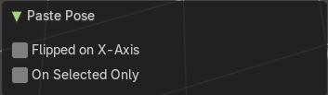
Last Operator Paste Pose

Flipped on X Axis
Paste the pose flipped along X Axis.

On Selected Only
Paste just on the selected bones. Not on the unselected.

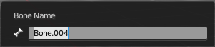
Rename active Bone
Calls a dialog where you can rename the active bone.

“Push Pose from Breakdown
Exaggerates the current pose. Pushes the current pose further away from the previous pose.

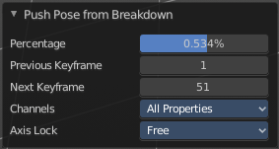
Last Operator Push Pose

Percentage
The percentage of exaggeration.

Previous Key frame
The key frame position before the current frame.

Next Key frame
The key frame position after the current frame.

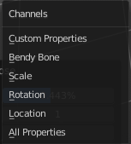
Channels
Limit the push effect to specific channels.

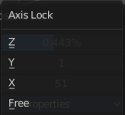
Axis Lock
Limit the push effect to specific axis.

Relax Pose to Breakdown
Relaxes the current pose.

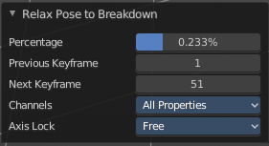
Last Operator Relax Pose to Breakdown

Percentage
The percentage of relaxing.

Previous Key frame
The key frame position before the current frame.

Next Key frame
The key frame position after the current frame.

Channels
Limit the relax effect to specific channels.

Axis Lock
Limit the relax effect to specific axis.

Pose Breakdowner
Creates a suitable breakdowner pose on the current frame.
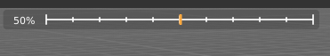
When you perform the tool then you will see a per cent slider in the header where you can read the percentual influence of the blending. Move the mouse to position the blend pose where you need it.

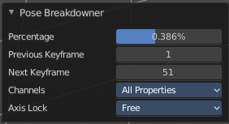
Last Operator Pose Breakdowner

Percentage
The percentage of exaggeration.

Previous Key frame
The key frame position before the current frame.

Next Key frame
The key frame position after the current frame.

Channels
Limit the breakdowner pose to specific channels.

Axis Lock
Limit the breakdowner pose to specific axis.

Blend to Neighbour
Blends the current pose with the neighbouring poses.
When you perform the tool then you will see a per cent slider in the header where you can read the percentual influence of the blending. Move the mouse to position the blend pose where you need it.

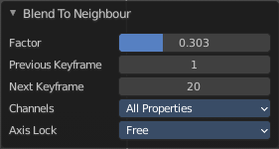
Last Operator Blend to Neighbour

Factor
The blend factor.

Previous Keyframe
The keyframe to calculate from before the current position.

Next Keyframe
The keyframe to calculate from after the current position.

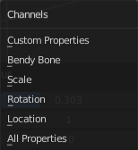
Channels

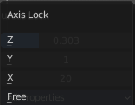
Axis Lock
Lock the transformation along an axis.

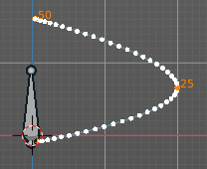
Calculate Motion Paths
Objects can be animated. Let's say you send them from a to b to c. The object will move to b, then to c. Some kind of a path. This path is not visible by default.
With motion paths you can calculate this path, and make it visible.

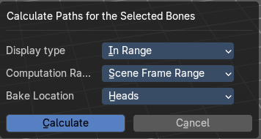
Calculate Motion path calls a setup dialog.

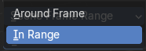
Display Type
How to display the motion path.

Around Frame
Display paths of poses within a fixed number of frames around the current frame.

In Range
Display paths of poses within specified frames.

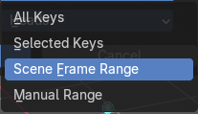
Computation Range
How much frames to compute.

All Keys
From the first keyframe to the last.

Selected Keys
From the first selected keyframe to the last.

Scene Frame Range
The entire scene / preview range.

Manual Range
Manually determined frame range.

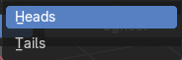
Bake Location
To bake from where.

Heads
Calculate bone paths from heads.

Tails
Calculate bone paths from tails.

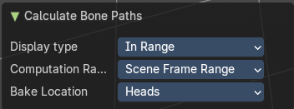
Last Operator Calculate Bone Paths
Same than the dialog.

Clear Motion Paths
Clear remove the motion path from the object.

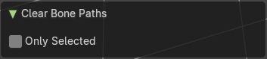
Last Operator Clear Bone Paths

Only Selected
Only clear motion patsh of selected bones.

Update Armature Motion Paths
Updates the motion paths for the armature object.

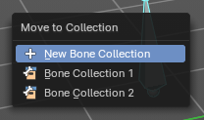
Move to Bone Collection
Armature and bones have their own collection system. This menu item opens a popup where you can put the selected bones into a New Collection or an existing Bone Collection.

New Bone Collection
Assigns the selected bones to a new Bone Collection. This will prompt to name the new collection.

Bone List
Assigns or unassigns the selected bones to or from the collection. The green + icon and red – icon show if you can remove or add a bone to the listed collection.

Show Hidden
Reveals the hidden bones.

Hide Selected
Hides the selected bones.

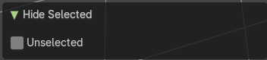
Last Operator Hide Selected

Unselected
Hide unselected bones too.

Hide Unselected
Makes all unselected bones hidden.

Clear User Transforms
Resets Pose of selected bones back to key frame state.

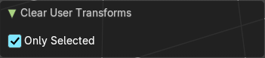
Last Operator Clear User Transforms

Only Selected
Only clear motion patsh of selected bones.

